Keep The Wolf From Our Door

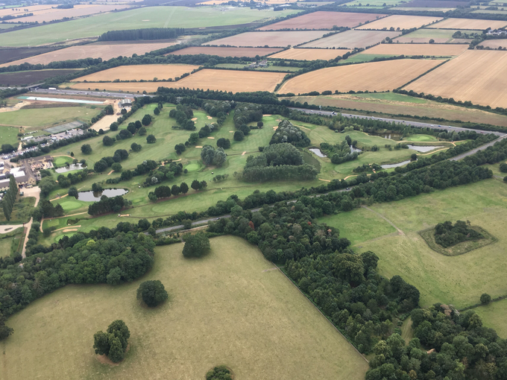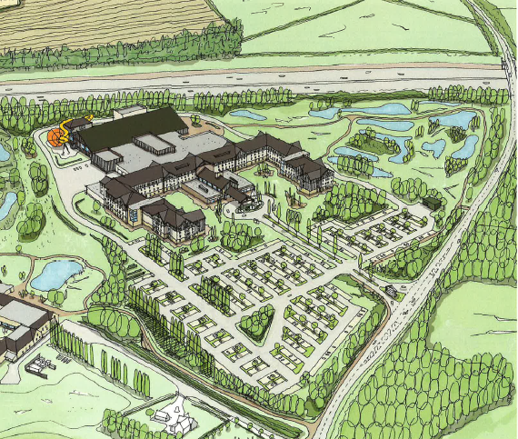

Stunningly landscaped greenfield site OR Urbanised development?

We Can Defeat This!

Great Wolf Resorts, an American water theme park company, are stopping at nothing to get their first park in the UK. Normally located on the edge of major American towns and cities, they are trying to force their way into the historic small village of Chesterton.

The residents of Chesterton and its golf club are set to lose 9 holes of its beautiful 18-hole golf course and much of its rich wildlife habitat. In its place they will be forced to endure:-

- 500,000 visitors per year to this vast private enterprise in a small village.
- 4 storey, 500 room hotel = more than 2,000 visitor daily capacity.
- Up to 1,000 additional cars daily on already congested local roads including A34, A41,A4095, B430.
- 84ft high water tower building and 900 space car park.
- 2,000 construction workers (+ major transport) on site for two-year construction period.
- Disruption of village lifestyle for thousands of residents in Chesterton and neighbouring villages.

Would you consider paying to stay at this resort? We recommend you experience the protracted and expensive on-line booking process at one of the USA sites.
Still considering it? Google “Great Wolf Resorts Complaints”. Also read the many negative reviews logged across numerous sites on Trip Advisor, ie. ‘rooms not clean’, ‘soiled sheets’, ‘food very poor quality and way too pricy’, very basic rooms’, ‘poor customer service’….
Great Wolf Boasts:-

- £200 million investment into the area.

- Family Entertainment Centre

- Will create 600 jobs locally

- Easy Access to Site

- The Golf Club will ‘retain’ 9 of its 18 holes!
Chesterton Parish Council Argues:-

- Post construction, no benefit to the local community! Food outlets (breakfast to dinner) & entertainment provided on site. 98% of guests in USA remain on site.

- NOT a public amenity! Hotel guests will take priority. Slight possibility that day passes may be available if booked 2 weeks in advance, subject to hotel occupancy. Very expensive – check USA website!

- Intend targeting young/inexpensive labour. Latest 2019 Cherwell unemployment/ jobseekers’ data indicates less than 70 on entire register?

- Village infrastructures unable to cope with 1,000 additional car movements per day. Yet more pressure on the M40, A34, A41, A4095 and B430. (Planned routing options include Wendlebury, Weston on the Green and Middleton Stoney; already beset with major traffic issues!). Plus additional major impact of air and noise pollution.

- Golf Club members will lose 9 of their much played 18 holes. Will the remaining 9 holes survive? The irreversible environmental damage to our rural community will be felt for generations to come.

This proposed development is not in the best interest of our community! For further information, please visit the following sites:-

Twitter @StopthewolfUK ,
Facebook: Stop the Wolf UK (public group)
Website: www.chestertonparishcouncil.org.uk/great-wolf

What can you do?
- Lobby your councillors and MPs. Join in local parish efforts at Weston on the Green, Middleton Stoney, Bucknell, Wendlebury, Kirtlington, Ardley with Fewcott, Launton, and Caversfield.
- Contribute to our ‘Wolf Lodge Fighting Fund’ Sort Code: 20-06-75 Account No: 83990192.
- Purchase car stickers and display posters available from clerk@chestertonparishcouncil.org.uk to demonstrate your opposition to this totally ill-placed proposal.

